

Students Name:………………………………………

SPECIALIST MATHEMATICS

TRIAL EXAMINATION 2

(ANALYSIS TASK)

2003

Reading Time: 15 minutes
Writing time: 90 minutes

Instructions to students
This exam consists of 5 questions.
All questions should be answered.
There is a total of 60 marks available.
The marks allocated to each of the five questions are indicated throughout.
Students may bring up to two A4 pages of pre-written notes into the exam.
The acceleration due to gravity should be taken to have magnitude 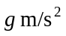where 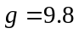
Formula sheets can be found on pages17-19 of this exam.

This paper has been prepared independently of the Victorian Curriculum and Assessment Authority to provide additional exam preparation for students. Although references have been reproduced with permission of the Victorian Curriculum and Assessment Authority, the publication is in no way connected with or endorsed by the Victorian Curriculum and Assessment Authority.

© THE HEFFERNAN GROUP 2003
This Trial Exam is licensed on a non transferable basis to the purchaser. It may be copied for educational use within the school which has purchased it. This license does not permit distribution or copying of this Trial Exam outside that school or by any individual purchaser.
Question 1

a. Let 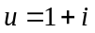

i. Write down 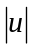

1 mark

ii. Write down 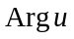.

1 mark

iii. Show on the Argand diagram below the complex number w where 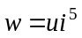.
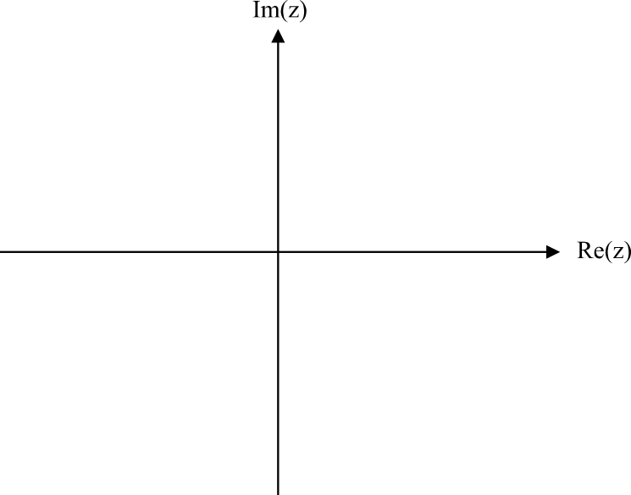

1 mark

iv. Hence, given that u and w are both roots of the equation 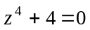, find the other roots of the equation. Give reasons for your answer.

2 marks

b. The equation 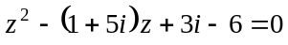 has a solution given by mi where m is real.

i. Find m.

2 marks

ii. Hence find all the solutions to the equation.

1 mark

c. The region R in the complex plane is defined by

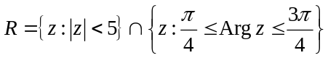 where 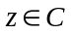.

i. Sketch R on the Argand diagram below.

2 marks
ii. The region R is reflected in the line defined by 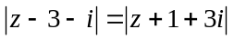 to create region S. Sketch S on the Argand diagram below.

2 marks

Total 12 marks

Question 2

Zac connects two plastic crates with a piece of rope, fills the crates with toys and pulls them up and down the hallway. He exerts a pulling force of P newtons acting at an angle of 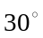 to the horizontal. The first crate has a mass of 4 kg and the second has a mass of 5 kg. The coefficient of friction between the hallway floor and the crates is 0.5. The diagram below shows Zac and his crates.

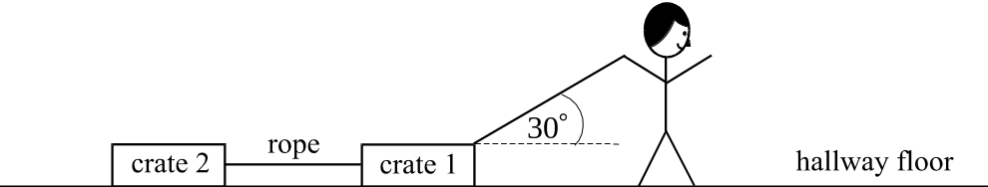

a. On the diagram above, label the weight force, the normal force, and the frictional force acting on each of the crates as well as the tension forces in the rope and the pulling force P.
2 marks

b. Zac exerts a pulling force of 43.55 N and the system of crates accelerates at 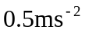 down the hallway. Find the tension in the rope. Express your answer correct to 1 decimal place.

3 marks
c. From the point where Zac starts accelerating down the hallway from rest, at
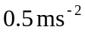, there is 20 metres of hallway left. How long can Zac keep accelerating down the hall at this rate before he reaches the end of the hallway? Express your answer correct to 1 decimal place.

2 marks

d. Zac stops and leaves the crates in the hallway. His younger brother Sam comes along and attempts to pull the crates along in exactly the same way as Zac had.
What is the minimum pulling force P (still acting at to the horizontal) that Sam would need to apply so that the crates are just on the point of sliding? Express your answer as an exact value.

4 marks
Total 11 marks

Question 3

The function f has a rule given by 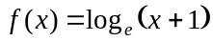.

a. Write down the maximal domain of f.

1 mark

b. Sketch the graph of 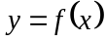 on the set of axes below, labelling clearly all the features.
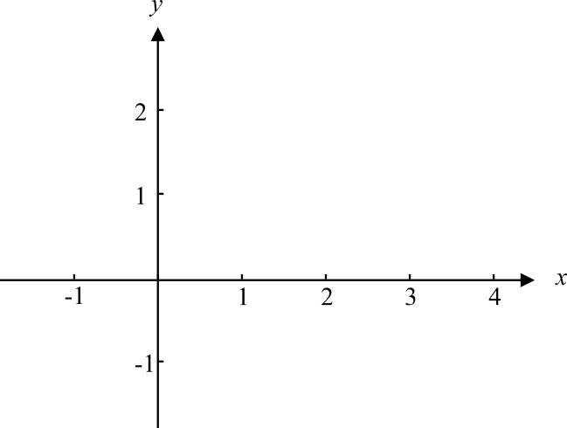

1 mark

c. Without using calculus, but by using your graph, explain why

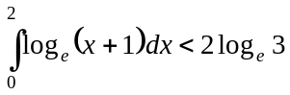

2 marks

d. Hence fill in the boxes below to complete the following inequality.
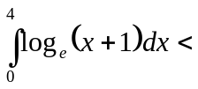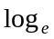

1 mark

e. i. Differentiate 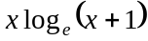.

1 mark

ii. Hence evaluate 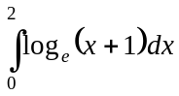.

2 marks

f. The area between the y-axis and the part of the graph of from 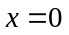 to 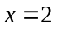 is rotated about the y-axis to form a solid of revolution.
Find the exact volume of this solid of revolution.

____________________________________________________________________

____________________________________________________________________

____________________________________________________________________

____________________________________________________________________

____________________________________________________________________

____________________________________________________________________

____________________________________________________________________

____________________________________________________________________

____________________________________________________________________
4 marks
Total 12 marks

Question 4

A particle of mass 4 kg is projected vertically upwards from a platform attached to the side of a city skyscraper with an initial speed of 10 metres per second.
The particle is subjected to a downwards gravitational force of 40 newtons and air resistance of 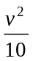 newtons in the opposite direction to the velocity, v, metres per second. The height of the particle at time, t, seconds is y metres.

a. Taking vertically upwards as the positive direction, explain why the equation of motion of the particle, until it reaches its maximum height, is given by 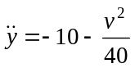.

1 mark

b. Given that 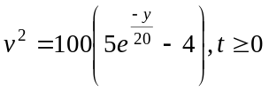 until the particle reaches its maximum height, find the maximum height. Express your answer as an exact value.

1 mark

c. Taking vertically downwards as the positive direction now, find the speed of the
particle as it returned to the platform given that it is subject to the same gravitational force and air resistance as before.

3 marks

d. If the platform were to be removed by the time the particle returned to its point of projection,

- Find an expression for the velocity of the particle as a function of time on the downward trip.

3 marks

ii. Find the terminal velocity of the particle.

1 mark

e. How long did it take the particle to fall from its maximum height to the position where the platform had been? Express your answer correct to 2 decimal places.

1 mark
Total 10 marks

Question 5

As part of a naval exercise, a fleet command ship is anchored out to sea at O.
The position of two aircraft carriers A and B, in relation to the fleet command ship is given respectively by the position vectors

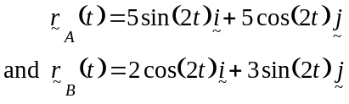

where t represents time in hours and where 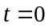 represents the start of the naval exercise.
The unit vector represents kilometres east of O, the unit vector represents kilometres north of O and the unit vector represents kilometres above sea level.

a. Describe the position of aircraft carrier A relative to the fleet command ship when the naval exercise started.

1 mark

b. Find the distance between the two aircraft carriers at the start of the naval exercise.

1 mark

c. In what direction is aircraft carrier A moving at the start of the naval exercise.

2 marks

d. Let equal the angle between the straight lines from aircraft carrier A to the fleet command ship and from aircraft carrier B to the fleet command ship.
Find , to the nearest minute, at 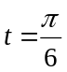 hours.

3 marks

e. i. Find the Cartesian equation of the path of aircraft carrier A.

1 mark

- Describe the path.

1 mark

f. Hence or otherwise explain whether or not the two aircraft carriers will collide.

2 marks

As part of the exercise a helicopter is supposed to land on aircraft carrier A. The position of the helicopter in relation to the fleet command ship is given by

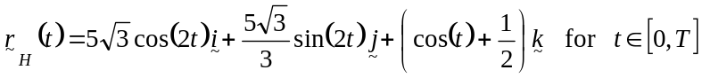

where corresponds to the start of the exercise and T corresponds to the time that the helicopter lands on the aircraft carrier. Assume that the aircraft carrier is at sea level.

g. i. Prove that, according to the position vector above, the helicopter can land on
the ship (assuming that there are no technical difficulties).

______________________________________________________________

______________________________________________________________

______________________________________________________________

______________________________________________________________

______________________________________________________________

______________________________________________________________

______________________________________________________________

______________________________________________________________
2 marks

ii. Hence write down the least value of t, which we refer to as T, when this
happens.

______________________________________________________________

______________________________________________________________
1 mark

h. Given that T is the value found in part g. ii., explain why the upper limit of the domain of the function

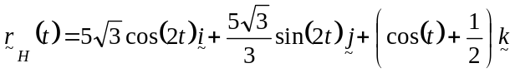

which describes the path of the helicopter should not be greater than T.

1 mark
Total 15 marks

Specialist Mathematics Formulas

Mensuration

area of a trapezium: 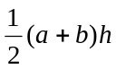
curved surface area of a cylinder: 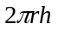
volume of a cylinder: 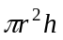
volume of a cone: 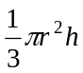
volume of a pyramid: 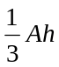
volume of a sphere: 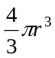
area of a triangle: 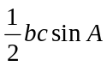
sine rule: 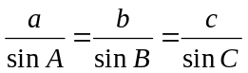
cosine rule: 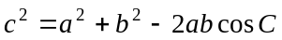

Coordinate geometry

ellipse: 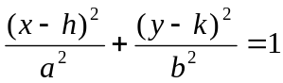
hyperbola: 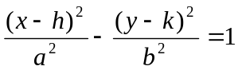

Circular (trigonometric) functions

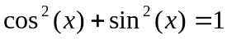
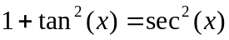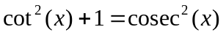
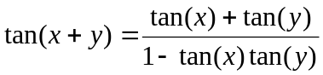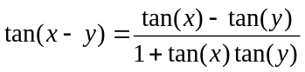
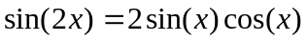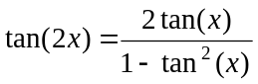
function | 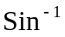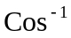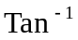
domain  range | 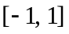  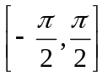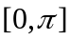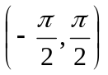
Reproduced with permission of the Victorian Curriculum and Assessment Authority.
(These formula sheets have been copied from the 2002 Specialist Maths Exam 2. Teachers and students are reminded that changes to formula sheets are notified in the VCE Bulletins and on the VCAA website.).

Algebra (Complex numbers)

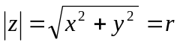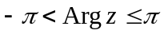
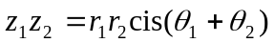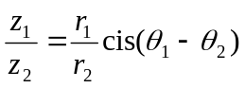
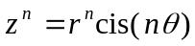 (de Moivre’s theorem)

Calculus

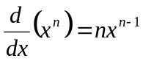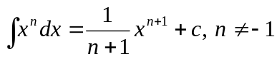
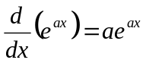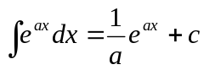
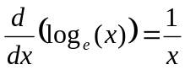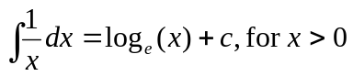
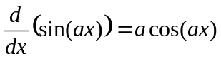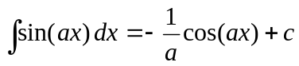
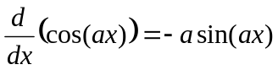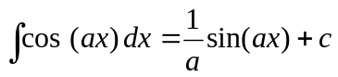
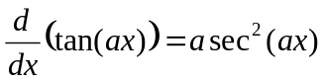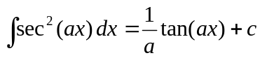
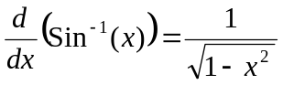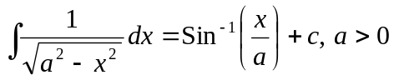
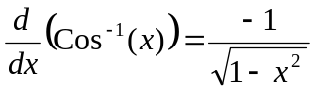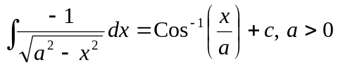
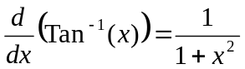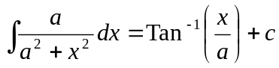

product rule: 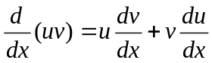
quotient rule: 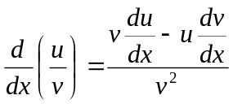
chain rule: 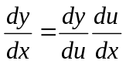

Reproduced with permission of the Victorian Curriculum and Assessment Authority.
(These formula sheets have been copied from the 2002 Specialist Maths Exam 2. Teachers and students are reminded that changes to formula sheets are notified in the VCE Bulletins and on the VCAA website.).
mid-point rule: 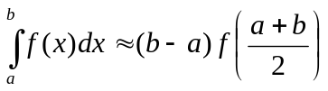
trapezoidal rule: 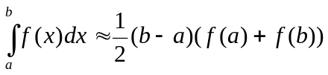
Euler’s method: 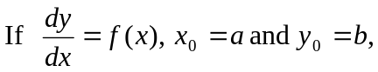
acceleration: 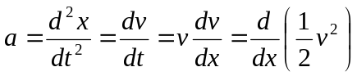
constant (uniform) acceleration: 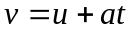 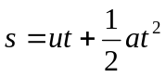 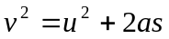 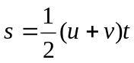

Vectors in two and three dimensions

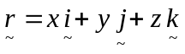
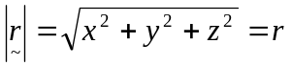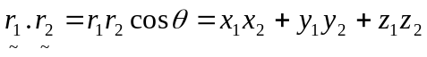
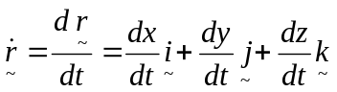

Mechanics

momentum: 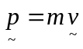
equation of motion: 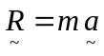
friction: 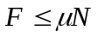

Reproduced with permission of the Victorian Curriculum and Assessment Authority.
(These formula sheets have been copied from the 2002 Specialist Maths Exam 2. Teachers and students are reminded that changes to formula sheets are notified in the VCE Bulletins and on the VCAA website.).

